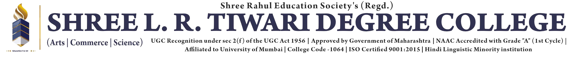

Nivestha: Invest Together, Prosper Together

A Project Report
Submitted in fulfilment of the

Requirements for the award of degree of

Bachelor of Science of (Data Science)
By

Krish Kiran Tare

Seat no: 3056832

Under the esteemed guidance of

Pragnesh Shah



DEPARTMENT OF DATA SCIENCE

SHREE L. R. TIWARI DEGREE COLLEGE OF ARTS, COMMERCE &
SCIENCE, Mira Road

(Affiliated to University of Mumbai)
THANE, 401107 MAHARASHTRA
2024-25

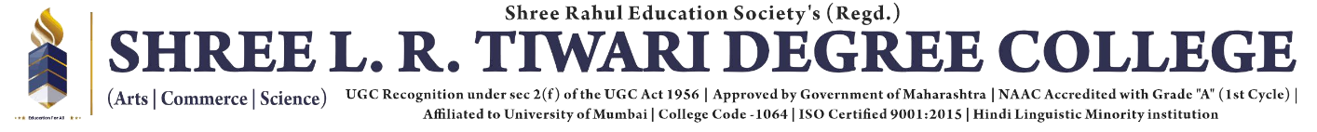

CERTIFICATE

Department of Bachelor Science of (Data Science)

This is to certify this project report entitled NIVESTHA: Invest Together, Prosper Together, submitted to University of Mumbai, Maharashtra is bonified record of work done by Krish Kiran Tare for Academic Year 2024-2025 under the guidance of “Pragnesh Shah” from to .

Date of Evaluation:

Internal Examiner College Stamp
(Guide)

External Examiner Head of the Depa

